IDEATION PHASE
Empathize & Discover

Date
Team ID | 6aba09485015c35b9862c9ac
Project Name | FitBuddy – AI Fitness Plan Generator using Gemini Models
Maximum Marks

Empathy Map Canvas
An empathy map is a simple and easy-to-understand tool that helps capture the thoughts, feelings, behaviours, and needs of FitBuddy users.
It helps the team understand the challenges users face while planning and maintaining their fitness routines. By considering the user's goals, preferences, motivations, and difficulties, the team can design a more personalized and user-friendly AI fitness solution using Gemini models.
Creating the empathy map helps FitBuddy understand the user's perspective and develop fitness plans that are practical, personalized, and easy to follow.

Example
EMPATHY MAP
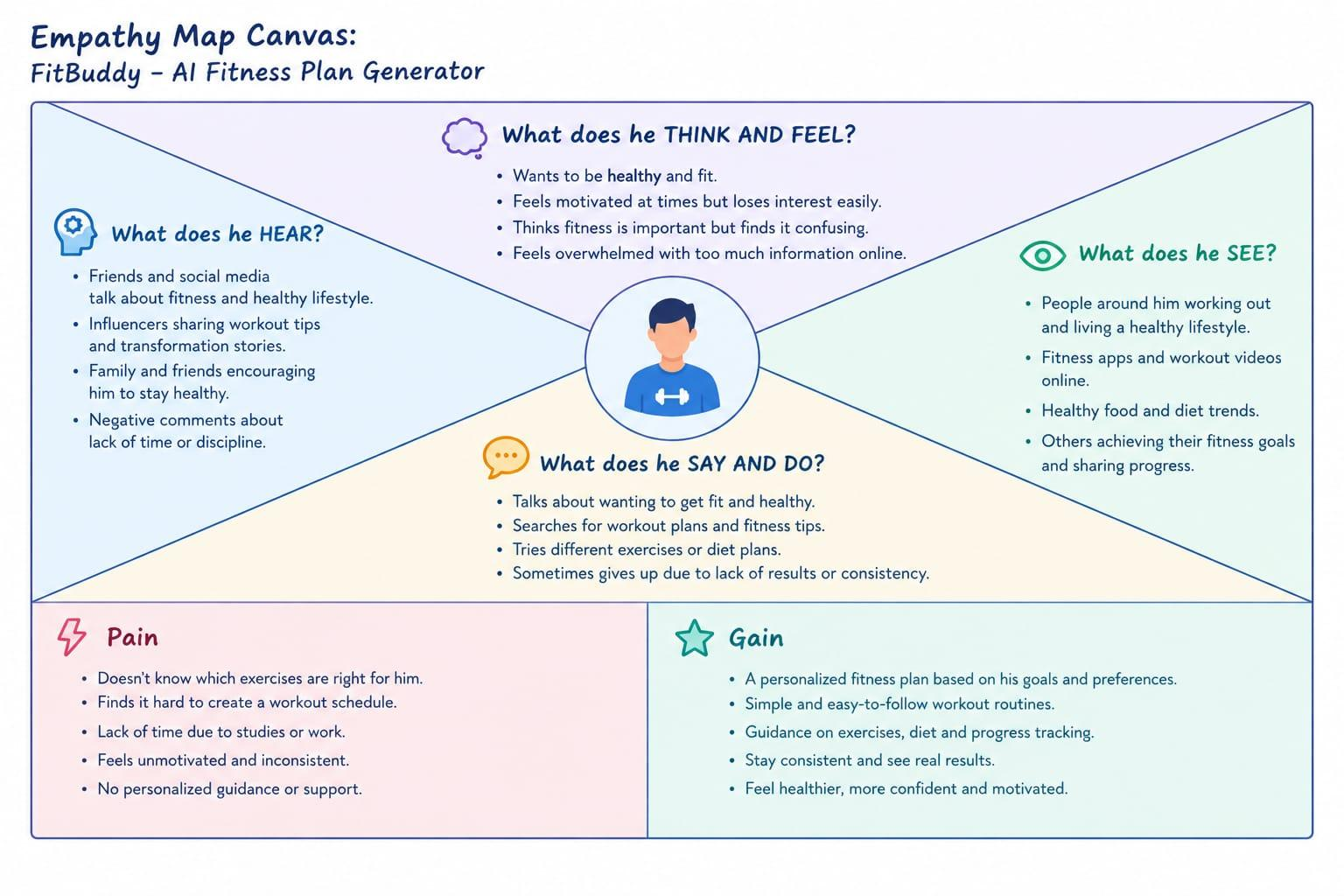

Reference

